Validation and Calibration of the Remote Consolidated Approach of Reporting on Food Security (rCARI) Methodology
Preliminary results from Myanmar, Ecuador, and Central African Republic
Version 1.2
Alirah Weyori* Nicole Wu Matthieu Tockert Mohamed Salem
October, 2023

Introduction
The overall goal of this study is to assess the validity of the rCARI module(s) against conventional CARI modules for measuring food security within the same population. The study compares the indicators measured through phone surveys with conventional face-to-face survey, considering the latter as the standard methodology. The following food security indicators are compared: Food Consumption Score (FCS), Livelihood Coping Strategies (LCS), reduced Coping Strategies Index (rCSI), Food Expenditure Share (FES), income sources and income change. The aggregation of these indicators into CARI and rCARI indices will be also compared. The Economic Capacity to Meet Essential Needs (ECMEN) indicator, which is sometimes used to aggregate CARI, will not be tested in this study (it requires the standard long expenditure module which cannot be implemented over the phone). In addition, the ECMEN calculation requires having an updated value of the minimum expenditure basket (MEB) of the study population, which is not available for the study areas. In its stead, a shortened version of the standard expenditure module will be used to test the possibility of collecting FES indicator over the phone.
Testing the comparability of these indicators through different modalities of data collection (Face-to-Face (F2F) vs. phone) should be read withing the wider consideration around phone survey modality of data collection. Several factors should be considered while reading estimates of any indicator (whether it is food security or not) when the data comes from a national phone survey using random techniques.
- First, mobile phone ownership (mobile phone penetration rate) could likely exclude the most vulnerable population from the sample.
- Second, mobile phone network coverage; Even in countries with high penetration rates, network coverage could be a problem, especially when electricity cuts are frequent and local infrastructure, such as communication masts, are not evenly distributed (World Bank, 2020).
- Third, response rate: It is well documented that the response rate in phone surveys is usually lower than in face-to-face surveys (L’Engle et al., 2018; World Bank, 2020). Response rate is usually lower among the well-off population which could contribute to sample skewness.
These factors usually lead to a skewed sample from phone surveys; nevertheless, there are several weighting techniques to adjust the results of phone surveys based on the demographics of the most recent face-to-face surveys (Nagpal et al. 2021; Glazerman et al. 2020; Valliant et al. 2013; Elkasabi, 2015).
In general, this study does not focus on weighting techniques to adjust for the sampling skewness and response rate as the primary objective is to test the validity of the phone modality to collect FS indicators. However, the study design adopted in Central African Republic CAR, could allow for testing of sample skewness due to mobile phone ownership and coverage (see CAR sample design in Annex III). CAR has one of the lowest mobile phone penetration rates globally (30% penetration rate).
The main objective of the study is to test the validity of food security indicators collected remotely over the phone against the conventional face-to-face modality. This includes testing mainly the indicators used to aggregate CARI and rCARI indices using a statistically identical sample of households. If needed, the validation will be followed by calibration to ensure that the modality of data collection has minimal influence on the estimate (rCARI).

Study design
The study was implemented in a randomized controlled setup to achieve the main objective. Food security data were collected from two statistically comparable groups of households within the same population. Standardized remote and face-to-face questionnaires were administered to the sampled households randomized to receive either of two modalities: remote or face-to-face. So far, the study has been implemented in three countries (Ecuador, CAR, and Myanmar) with additional three countries planned to start soon.

Selection of study areas and participants
After taking informed consent from potential participants/respondents, listing of households in the study areas was done to serve as the sampling frame for randomization. In Myanmar, which was the first country of data collection, the initial sample frame was 1665 households drawn from an old WFP beneficiary list from some 20 IDP (Internally Displaced Persons) camps. This list of households was used for the randomization. In Ecuador and CAR, we conducted the listing of potential households one week before the data collection exercise and increased the listed households to at least 2000 households to serve as sampling frame for randomization. Demographic information was collected from all listed households during the listing phase in Ecuador and CAR. The listed households were then randomly assigned to receive one of two modalities; (half of the sample) received the remote/phone interview (called the treatment group) and the remaining half received face-to-face interview (called the control group). The study targeted a minimum of 600 completed interviews for each modality.

Response rate
Table 1 shows the total sample as well as interviews completed in the initial 3 countries of the study.
Table 1: Survey Completion by Country
 |  | Country
 | Myanmar | Ecuador | CAR | Total
N | 1,665 (27.2%) | 2,372 (38.8%) | 2,080 (34.0%) | 6,117 (100.0%)
Survey Progress Not Completed | 572 (34.4%) | 956 (40.3%) | 835 (40.1%) | 2,363 (38.6%)
Completed | 1,093 (65.6%) | 1,416 (59.7%) | 1,245 (59.9%) | 3,754 (61.4%)
Survey Modality  Face-to-Face | 610 (55.8%) | 760 (53.7%) | 969 (77.8%) | 2,339 (62.3%)
Remote | 483 (44.2%) | 656 (46.3%) | 276 (22.2%) | 1,415 (37.7%)

The response rate in the remote sample was lower than the F2F in all three countries. However, this did not influence the sample balance for almost all the collected background information at household level for Ecuador and Myanmar. In CAR, we used a sub-sample of balanced households among the phone owners for this preliminary analysis. For more details about response rate, the final sample used in this analysis and the statistical balance test (see Annex I and III).

Primary Results: Impact of Survey Modality

CARI vs. rCARI
For this analysis, three different versions of CARI are tested against the standard version of CARI. The definitions of the different versions are present below.
Conventional/standard CARI: CARI-FES: Standard CARI using FES from F2F surveys.
Other ways of aggregating CARI (that are tested)
- rCARI-FES: Standard CARI using FES in but coming from remote surveys.
- CARI-Inc: CARI using income variable coming from F2F surveys.
- rCARI-Inc: Standard rCARI using Income and income change variable coming from remote surveys (this is the CARI version that was used during COVID 19 Pandemic).
Table 2 shows the different methodologies of calculating CARI to test their performance with the standard/conventional CARI.

Table 2: Indicator and CARI Versions considered
 | Indicators used in the aggregation
 | Standard CARI | Comparison versions
Indicator | CARI-FES  (F2F) | CARI-inc  (F2F) | rCARI-FES  (Remote) | rCARI-inc  (Remote)
FCS | Yes | Yes | Yes | Yes
FES | Yes | No | Yes | No
LCS | Yes | Yes | Yes | Yes
rCSI | Yes | Yes | Yes | Yes
Income source & income change | No | Yes | No | Yes

For more information on the calculation of each of the food security indicators, see Annex IV

Table 3: Impact of Survey Modality: Standard CARI-FES vs. rCARI-Inc
 | Myanmar |  |  | Ecuador |  |  | CAR
Variable | F2F | Remote | Diff | F2F | Remote | Diff | F2F | Remote | Diff
Food Secure | 0.08 | 0.07 | -0.01 | 0.01 | 0.00 | -0.01 | 0.01 | 0.01 | -0.00
 | (0.27) | (0.26) | (0.67) | (0.11) | (0.07) | (0.08) | (0.08) | (0.08) | (0.96)
Marginally Food Secure | 0.44 | 0.41 | -0.03 | 0.23 | 0.27 | 0.03 | 0.31 | 0.52 | 0.21***
 | (0.50) | (0.49) | (0.42) | (0.42) | (0.44) | (0.13) | (0.46) | (0.50) | (0.00)
Moderately Food Insecure | 0.44 | 0.49 | 0.05 | 0.59 | 0.62 | 0.03 | 0.60 | 0.45 | -0.15**
 | (0.50) | (0.50) | (0.23) | (0.49) | (0.48) | (0.22) | (0.49) | (0.50) | (0.00)
Severely Food Insecure | 0.03 | 0.03 | -0.01 | 0.16 | 0.11 | -0.06** | 0.08 | 0.02 | -0.06**
 | (0.18) | (0.16) | (0.59) | (0.37) | (0.31) | (0.00) | (0.27) | (0.14) | (0.00)
Food Insecure | 0.47 | 0.51 | 0.04 | 0.76 | 0.73 | -0.03 | 0.68 | 0.47 | -0.21***
 | (0.50) | (0.50) | (0.31) | (0.43) | (0.44) | (0.26) | (0.47) | (0.50) | (0.00)
Observations | 610 | 232 | 842 | 760 | 656 | 1,416 | 294 | 157 | 451
Note: Significance: * p<0.05, ** p<0.01, *** p<0.001.
Table 3 presents the first results comparing the rCARI using income sources and income change (rCARI-Inc) with the standard CARI (CARI-FES). The results of this analysis showed a number of key findings.
First, in Myanmar and Ecuador, the reported food insecurity prevalence (moderately food insecure plus severely food insecure) did not differ significantly between the two aggregation methodologies. However, in CAR, rCARI-inc underestimated the prevalence of food insecurity by 21 percentage points compared to the CARI-FES.
Second, the rCARI-Inc was identical to CARI-FES in estimating the percentage of moderately food insecure in Myanmar and Ecuador but underestimated the severely food insecure in Ecuador by 6 percentage points. In CAR, rCARI-Inc significantly underestimated the moderately food insecure numbers and severely food insecure by 15 points and 6 points respectively compared to CARI-FES.

Table 4: Impact of Survey Modality: CARI-FES vs. rCARI-FES
 | Myanmar |  |  | Ecuador |  |  | CAR
Variable | F2F | Remote | Diff | F2F | Remote | Diff | F2F | Remote | Diff
Food Secure | 0.08 | 0.03 | -0.06*** | 0.01 | 0.00 | -0.01** | 0.01 | 0.01 | -0.00
 | (0.27) | (0.16) | (0.00) | (0.11) | (0.04) | (0.01) | (0.08) | (0.08) | (0.96)
Marginally Food Secure | 0.44 | 0.34 | -0.10** | 0.23 | 0.07 | -0.16*** | 0.31 | 0.29 | -0.02
 | (0.50) | (0.48) | (0.01) | (0.42) | (0.26) | (0.00) | (0.46) | (0.45) | (0.61)
Moderately Food Insecure | 0.44 | 0.57 | 0.13*** | 0.59 | 0.69 | 0.10*** | 0.60 | 0.58 | -0.02
 | (0.50) | (0.50) | (0.00) | (0.49) | (0.46) | (0.00) | (0.49) | (0.50) | (0.65)
Severely Food Insecure | 0.03 | 0.06 | 0.02 | 0.16 | 0.23 | 0.07** | 0.08 | 0.13 | 0.05
 | (0.18) | (0.23) | (0.17) | (0.37) | (0.42) | (0.00) | (0.27) | (0.33) | (0.14)
Food Insecure | 0.47 | 0.63 | 0.16*** | 0.76 | 0.92 | 0.17*** | 0.68 | 0.71 | 0.02
 | (0.50) | (0.48) | (0.00) | (0.43) | (0.27) | (0.00) | (0.47) | (0.46) | (0.61)
Observations | 610 | 232 | 842 | 760 | 656 | 1,416 | 294 | 157 | 451
Note: Significance: * p<0.05, ** p<0.01, *** p<0.001.
Table 4 shows the results of rCARI aggregated using the FES module collected over the phone (rCARI-FES) in comparison to the standard CARI collected through F2F (CARI-FES). This represents the scenario of collecting all CARI indicators, expenditure included, over phone. The expenditure module collected over phone was a relatively shorter version that collects aggregate expenditure without going through individual items.
The results show that rCARI using FES consistently overestimates the number of food insecure across all countries compared to the standard CARI by between 2 and 17 percentage points. This difference was statistically significant in Myanmar and Ecuador.
Table 5: Impact of Indicator Composition: Paired CARI-FES vs. CARI-Inc in F2F Surveys
 | Myanmar |  |  | Ecuador |  |  | CAR
Food Security Category | CARI-FES | CARI-Inc | Diff | CARI-FES | CARI-Inc | Diff | CARI-FES | CARI-Inc | Diff
Food Secure | 0.08 | 0.16 | 0.08*** | 0.01 | 0.03 | 0.02 | 0.01 | 0.02 | 0.01*
 | (0.01) | (0.01) | (0.01) | (0.00) | (0.01) | (0.01) | (0.00) | (0.01) | (0.01)
Marginally Food Secure | 0.44 | 0.43 | -0.01 | 0.23 | 0.33 | 0.10*** | 0.31 | 0.51 | -0.20***
 | (0.02) | (0.02) | (0.02) | (0.02) | (0.02) | (0.02) | (0.03) | (0.03) | (0.03)
Moderately Food Insecure | 0.44 | 0.39 | -0.05** | 0.59 | 0.53 | -0.06** | 0.60 | 0.45 | -0.16***
 | (0.02) | (0.02) | (0.02) | (0.02) | (0.02) | (0.02) | (0.03) | (0.03) | (0.03)
Severely Food Insecure | 0.03 | 0.02 | -0.01* | 0.16 | 0.11 | -0.06*** | 0.08 | 0.02 | -0.06***
 | (0.01) | (0.01) | (0.01) | (0.01) | (0.01) | (0.01) | (0.02) | (0.01) | (0.02)
Food Insecure | 0.47 | 0.41 | -0.06*** | 0.76 | 0.64 | - 0.12*** | 0.68 | 0.47 | -0.22***
 | (0.02) | (0.02) | (0.02) | (0.02) | (0.02) | (0.02) | (0.03) | (0.03) | (0.03)
Observations | 610 | 610 | 610 | 760 | 760 | 760 | 294 | 294 | 294

Table 5 represents the comparison between conventional CARI aggregate (CARI-FES) against CARI calculation using income sources and income changes (CARI-Inc) from the same households in the F2F sample only. The paired analysis showed that, the CARI-Inc was conservative in measuring food insecurity by (6 - 22 points) in the three countries.

Comparing the different indicators used in CAR and rCARI aggregation could explain some of the differences between the standard aggregation method (CARI-FES) and the three different suggested aggregations (two from remote survey rCARI-inc, rCARI- FES) and a newly suggested aggregation for CARI (CARI-inc)

FCS
Looking at the results of FCS in Myanmar, there is no significant difference in the average FCS and different categories of FCS classification between the modalities (F2F and remote). In Ecuador and CAR, the results show that respondents tend to slightly overestimate their consumption (report better consumption) over the phone than when they were interviewed in F2F. However, the difference not wide (between 6 and 8 points on average) and largely driven by higher reporting on the diary and protein in the phone survey (see Table 6 for details).

Table 6: Impact of Survey Modality on Food Consumption Score and Groups
 | Myanmar |  |  | Ecuador |  |  | CAR
Variable | F2F | Remote | Diff | F2F | Remote | Diff | F2F | Remote | Diff
Food Consumption Score | 44.32 | 43.75 | -0.57 | 46.28 | 52.54 | 6.25*** | 39.76 | 47.63 | 7.87***
 | (12.36) | (12.15) | (0.45) | (21.57) | (24.12) | (0.00) | (17.58) | (17.45) | (0.00)
FCS: Acceptable | 0.54 | 0.48 | -0.06 | 0.54 | 0.62 | 0.09*** | 0.40 | 0.58 | 0.18***
 | (0.50) | (0.50) | (0.07) | (0.50) | (0.49) | (0.00) | (0.49) | (0.50) | (0.00)
FCS: Borderline | 0.40 | 0.45 | 0.05 | 0.24 | 0.22 | -0.02 | 0.35 | 0.29 | -0.06
 | (0.49) | (0.50) | (0.09) | (0.43) | (0.42) | (0.35) | (0.48) | (0.45) | (0.19)
FCS: Poor | 0.06 | 0.07 | 0.00 | 0.22 | 0.16 | -0.07** | 0.25 | 0.13 | -0.12**
 | (0.24) | (0.25) | (0.79) | (0.42) | (0.36) | (0.00) | (0.43) | (0.34) | (0.00)
Consumption over the past 7 days (cereals and tubers) | 7.00 | 7.00 | 0.00 | 5.38 | 4.93 | -0.45*** | 5.87 | 6.24 | 0.36*
 | (0.12) | (0.00) | (0.32) | (2.28) | (2.32) | (0.00) | (1.86) | (1.33) | (0.02)
Consumption over the past 7 days (pulses) | 1.63 | 1.82 | 0.20* | 2.00 | 2.50 | 0.50*** | 3.74 | 3.74 | -0.01
 | (1.46) | (1.55) | (0.03) | (2.06) | (2.24) | (0.00) | (2.33) | (2.08) | (0.98)
Consumption over the past 7 days (dairy products) | 0.17 | 0.18 | 0.01 | 1.38 | 2.03 | 0.65*** | 0.50 | 1.14 | 0.64**
 | (0.67) | (0.62) | (0.79) | (2.02) | (2.32) | (0.00) | (1.57) | (2.27) | (0.00)
Consumption over the past 7 days (protein-rich foods) | 3.22 | 3.01 | -0.21 | 3.03 | 3.48 | 0.44*** | 1.72 | 2.09 | 0.37*
 | (2.05) | (1.97) | (0.09) | (2.42) | (2.39) | (0.00) | (1.81) | (1.81) | (0.04)
Consumption over the past 7 days (vegetables) | 6.42 | 6.48 | 0.06 | 3.93 | 4.75 | 0.82*** | 3.73 | 5.64 | 1.92***
 | (1.36) | (1.21) | (0.43) | (2.82) | (2.56) | (0.00) | (2.93) | (1.66) | (0.00)
Consumption over the past 7 days (fruit) | 1.73 | 1.43 | -0.30** | 2.58 | 2.90 | 0.31* | 0.54 | 0.72 | 0.18
 | (1.92) | (1.67) | (0.01) | (2.57) | (2.61) | (0.02) | (1.31) | (1.34) | (0.17)
Consumption over the past 7 days (oil) | 6.67 | 6.37 | -0.30*** | 5.38 | 5.40 | 0.02 | 4.90 | 5.79 | 0.89***
 | (1.21) | (1.31) | (0.00) | (2.52) | (2.34) | (0.87) | (2.37) | (1.81) | (0.00)
Consumption over the past 7 days (sugar) | 0.82 | 0.85 | 0.03 | 5.39 | 5.64 | 0.25* | 2.36 | 3.53 | 1.17***
 | (1.50) | (1.58) | (0.74) | (2.57) | (2.25) | (0.05) | (2.60) | (2.78) | (0.00)
Observations | 610 | 483 | 1,093 | 760 | 656 | 1,416 | 294 | 157 | 451
Note: Significance: * p<0.05, ** p<0.01, *** p<0.001.

rCSI
The rCSI results in Table 7 show that in Myanmar and CAR households tend to report adopting more reduced coping strategies when asked over the phone compared to the households interviewed through F2F. However, the opposite is found for Ecuador where F2F respondents report adopting higher reduced coping strategies their remote counterparts. Although the direction of the difference is not consistent across the countries, the differences in rCSI scores remain very minimal ranges from -1.3 to +3.8 points. Since the rCSI indicator has a low overall weight in the CARI aggregate, this minimal change in reporting between F2F and remote would have a negligible impact on the overall CARI index.

Table 7: Impact of Survey Modality on Reduced Coping Strategy Index and IPC Phases
 | Myanmar |  |  | Ecuador |  |  | CAR
Variable | F2F | Remote | Diff | F2F | Remote | Diff | F2F | Remote | Diff
Reduced Coping Strategies Index (rCSI) | 5.43 | 9.24 | 3.81*** | 19.86 | 18.50 | -1.36* | 14.35 | 17.27 | 2.92**
 | (7.46) | (8.87) | (0.00) | (12.41) | (11.68) | (0.03) | (9.97) | (8.88) | (0.00)
rCSI: Low | 0.59 | 0.31 | -0.29*** | 0.08 | 0.06 | -0.02 | 0.06 | 0.04 | -0.02
 | (0.49) | (0.46) | (0.00) | (0.28) | (0.24) | (0.09) | (0.25) | (0.21) | (0.36)
rCSI: Median | 0.33 | 0.53 | 0.20*** | 0.44 | 0.51 | 0.08** | 0.70 | 0.57 | -0.14**
 | (0.47) | (0.50) | (0.00) | (0.50) | (0.50) | (0.00) | (0.46) | (0.50) | (0.00)
rCSI: Severe | 0.08 | 0.17 | 0.09*** | 0.48 | 0.43 | -0.05 | 0.23 | 0.39 | 0.16***
 | (0.26) | (0.37) | (0.00) | (0.50) | (0.50) | (0.05) | (0.42) | (0.49) | (0.00)
Relied on less preferred, less expensive food | 1.92 | 2.86 | 0.94*** | 4.41 | 4.56 | 0.15 | 3.92 | 2.75 | -1.17***
 | (2.20) | (2.26) | (0.00) | (2.58) | (2.71) | (0.29) | (2.00) | (1.84) | (0.00)
Borrowed food or relied on help from friends or relatives | 0.59 | 0.56 | -0.03 | 1.64 | 1.75 | 0.11 | 0.77 | 0.89 | 0.12
 | (1.20) | (1.13) | (0.69) | (1.95) | (2.13) | (0.33) | (1.15) | (1.25) | (0.32)
Reduced portion size of meals at meals time | 0.56 | 0.74 | 0.18* | 3.80 | 3.27 | -0.53*** | 1.98 | 2.65 | 0.67**
 | (1.32) | (1.42) | (0.03) | (2.70) | (2.85) | (0.00) | (2.27) | (2.14) | (0.00)
Restricted consumption by adults in order for young children to eat | 0.52 | 1.23 | 0.72*** | 1.87 | 1.51 | -0.36** | 1.73 | 2.70 | 0.97***
 | (1.39) | (1.78) | (0.00) | (2.38) | (2.24) | (0.00) | (1.90) | (1.83) | (0.00)
Reduced the number of meals eaten per day | 0.22 | 0.82 | 0.60*** | 2.77 | 2.66 | -0.11 | 1.74 | 2.00 | 0.26
 | (0.90) | (1.67) | (0.00) | (2.52) | (2.70) | (0.43) | (2.38) | (2.12) | (0.24)
Observations | 610 | 483 | 1,093 | 760 | 656 | 1,416 | 294 | 157 | 451
Note: Significance: * p<0.05, ** p<0.01, *** p<0.001.

LCS
The livelihood coping strategies indicator is the only indicator that showed consistency higher reporting on the adoption of most of the strategies, in the three countries (see Annex 2).
In Myanmar and CAR, using the 4 LCS categories, more households were classified in crisis plus emergency categories in the remote group compared to face to face (18 to 28 percentage points difference) (see table 8 combining crisis + emergency categories).
In Ecuador, there is unexplained overreporting on the emergency coping strategy, which gives a massive 50 points difference. This was driven by misreporting on the household engagement in illegal activities and begging in the phone survey (see annex 2). The over-reporting of emergency coping led to under classification of crisis coping in Ecuador (as the indicator take the maximum severity of coping strategy applied by the HH). However, both percentage of crisis +emergency in Ecuador is still higher in the phone group than the F2F by 27 percentage points. Further investigation is needed to explain these results.
Table 8: Impact of Survey Modality on Livelihood Coping Strategy Index
 | Myanmar |  |  | Ecuador |  |  | CAR
Variable | F2F | Remote | Diff | F2F | Remote | Diff | F2F | Remote | Diff
Maximum Livelihood Coping: None | 0.26 | 0.12 | -0.14*** | 0.09 | 0.02 | -0.07*** | 0.20 | 0.11 | -0.09*
 | (0.44) | (0.32) | (0.00) | (0.29) | (0.14) | (0.00) | (0.40) | (0.32) | (0.01)
Maximum Livelihood Coping: Stress level | 0.46 | 0.41 | -0.05 | 0.28 | 0.08 | -0.20*** | 0.61 | 0.43 | -0.19***
 | (0.50) | (0.49) | (0.10) | (0.45) | (0.28) | (0.00) | (0.49) | (0.50) | (0.00)
Maximum Livelihood Coping: Crisis level | 0.25 | 0.33 | 0.08** | 0.42 | 0.19 | -0.23*** | 0.14 | 0.26 | 0.13**
 | (0.43) | (0.47) | (0.00) | (0.49) | (0.39) | (0.00) | (0.34) | (0.44) | (0.00)
Maximum Livelihood Coping: Emergency level | 0.03 | 0.14 | 0.10*** | 0.21 | 0.70 | 0.50*** | 0.05 | 0.20 | 0.15***
 | (0.18) | (0.35) | (0.00) | (0.41) | (0.46) | (0.00) | (0.22) | (0.40) | (0.00)
Observations | 610 | 483 | 1,093 | 760 | 656 | 1,416 | 294 | 157 | 451
Note: Significance: * p<0.05, ** p<0.01, *** p<0.001.

FES
The average food expenditure share was over reported among the phone respondents across the 3 countries; However, the difference was minimal (5 to 8 points). However, when classifying FES using the CARI cut-offs the differences for those who were classified in the worst category (spending more than 75% on food) was larger (10 to 19 percentage points).
Table 9: Impact of Survey Modality on Expenditure and Food Expenditure Share
 | Myanmar |  |  | Ecuador |  |  | CAR
Variable | F2F | Remote | Diff | F2F | Remote | Diff | F2F | Remote | Diff
Food Expenditure Share | 0.66 | 0.71 | 0.05*** | 0.71 | 0.79 | 0.08*** | 0.67 | 0.73 | 0.06*
 | (0.15) | (0.14) | (0.00) | (0.19) | (0.16) | (0.00) | (0.20) | (0.24) | (0.01)
FES < 50 percent | 0.13 | 0.08 | -0.06* | 0.15 | 0.05 | -0.10*** | 0.20 | 0.16 | -0.04
 | (0.34) | (0.27) | (0.01) | (0.36) | (0.22) | (0.00) | (0.40) | (0.37) | (0.27)
FES: 50-65 percent | 0.30 | 0.22 | -0.08* | 0.17 | 0.09 | -0.08*** | 0.23 | 0.17 | -0.06
 | (0.46) | (0.41) | (0.01) | (0.38) | (0.29) | (0.00) | (0.42) | (0.38) | (0.15)
FES: 65-75 percent | 0.27 | 0.26 | -0.01 | 0.19 | 0.18 | -0.01 | 0.13 | 0.13 | -0.01
 | (0.44) | (0.44) | (0.76) | (0.39) | (0.38) | (0.54) | (0.34) | (0.33) | (0.87)
FES: >= 75 percent | 0.30 | 0.45 | 0.15*** | 0.49 | 0.68 | 0.19*** | 0.44 | 0.54 | 0.10*
 | (0.46) | (0.50) | (0.00) | (0.50) | (0.47) | (0.00) | (0.50) | (0.50) | (0.04)
Observations | 610 | 232 | 842 | 760 | 656 | 1,416 | 294 | 157 | 451
Note: Significance: * p<0.05, ** p<0.01, *** p<0.001
In Myanmar, the Short Form in Remote Survey was dropped due to translation issues.

Income source and change in income indicator
Across the three countries, there is lower reporting on the most severe category of the income sources in the remote survey compared to F2F survey. However, the difference is minimal (0.4 to 8 points) and only significant in Myanmar and Ecuador. For the third category of the income source indicator, there was no statistically significant results between the modalities except in CAR where remote survey estimated higher prevalence by 11 points.
Table 10: Impact of Survey Modality on Income
 | Myanmar |  |  | Ecuador |  |  | CAR
Variable | F2F | Remote | Diff | F2F | Remote | Diff | F2F | Remote | Diff
Income: Regular and Unchanged/Increasing | 0.22 | 0.19 | -0.03 | 0.19 | 0.25 | 0.06** | 0.45 | 0.26 | -0.19***
 | (0.41) | (0.39) | (0.30) | (0.40) | (0.44) | (0.01) | (0.50) | (0.44) | (0.00)
Income: Regular and Reduced OR Irregular and Unchanged/Increasing | 0.39 | 0.41 | 0.03 | 0.38 | 0.41 | 0.03 | 0.42 | 0.50 | 0.08
 | (0.49) | (0.49) | (0.36) | (0.49) | (0.49) | (0.25) | (0.49) | (0.50) | (0.13)
Income: Irregular and Reduced | 0.28 | 0.33 | 0.04 | 0.26 | 0.24 | -0.01 | 0.12 | 0.23 | 0.11**
 | (0.45) | (0.47) | (0.11) | (0.44) | (0.43) | (0.54) | (0.32) | (0.42) | (0.00)
Income: No income sources | 0.11 | 0.07 | -0.05** | 0.17 | 0.09 | -0.08*** | 0.01 | 0.01 | -0.00
 | (0.32) | (0.25) | (0.01) | (0.37) | (0.29) | (0.00) | (0.12) | (0.11) | (0.94)
Observations | 610 | 483 | 1,093 | 760 | 656 | 1,416 | 294 | 157 | 451
Note: Significance: * p<0.05, ** p<0.01, *** p<0.001.

Comparison between prevalence of HH classified in food insecurity groups by FES versus income indicators.
In general, the absolute prevalence of income source indicator in category 3 and 4 (irregular income and reduced plus no income sources) is much lower than the FES coming from the same source (F2F survey).
Table 11: Impact of Survey Modality on Income
 | MMR | ECU | CAR |  | MMR | ECU | CAR
Income source | F2F | F2F | F2F | FES | F2F | F2F | F2F
Income: Irregular and Reduced | 0.28 | 0.26 | 0.12 | FES: 65-75 percent | 0.27 | 0.19 | 0.13 | 0.01 | 0.07 | -0.01
Income: No income sources | 0.11 | 0.17 | 0.01 | FES: >= 75 percent | 0.30 | 0.49 | 0.44 | -0.19 | -0.32 | -0.43
Income: irregular+ no income | 0.39 | 0.43 | 0.13 | FES>= 65 | 0.57 | 0.68 | 0.57 | -0.18 | -0.25 | -0.44
Observations | 610 | 760 | 294 |  | 610 | 760 | 294 | 610 | 760 | 294

The table shows that replacing FES with income source in the rCARI or CARI aggregates will lead to significantly lower estimation of food insecurity (difference ranged between 18 to 44 percentage points).

Preliminary conclusion from 3 countries
Disclaimer: the following conclusions are preliminary based on the data collected from the initial 3 pilot countries and thus should be interpreted with the following caveats. First, the results from CAR are based on a sub-sample of the overall sample (only phone owners’ sub-sample). Also, in Myanmar results of FES and rCARI are based on half of the sampled households in the remote group (see Annex I and II for more details).
From the preliminary analysis of the available data the below could be initially concluded.
- rCARI using income & income change indicator (rCARI-Inc) is not statistically different from the standard/conventional CARI (CARI-FES) when used in Myanmar & Ecuador. In CAR, where it is significantly different, (rCARI-Inc) tends to underestimate food insecurity by 21 percentage points.
- Analysing (CARI-Inc) and (CARI-FES) from the same households interviewed through F2F modality revealed that (CARI-Inc) leads to lower food insecurity estimation by 6 to 22 percentage points.
- FCS, rCSI, FES and income sources indicators collected over phone tend to give similar or slightly different results than F2F data collection. Differences in FCS (0 to 8 points), rCSI (-1 to 4 points) FES (5-8 points), and income sources (0 to 8 percentage points in category 4) (1 to 11 percentage points in category 3)
- LCS collected over phone tends to produce higher estimation of food insecurity than those collected from face to face. The difference is LCS crisis + emergency coping is (18 to 28 percentage points).
- Regardless of the modality of the collection, the absolute prevalence of the FES indicator (looking at category 3 and 4, i.e., FES > 65%) is much higher than the absolute prevalence of the income source indicator (looking at irregular income + no income categories). The difference between the income source and FES prevalence coming from the F2F group was 18 percentage points (PP) in Myanmar, 25 PP in Ecuador and 44 PP in CAR.
- Although LCS over estimated food insecurity in the three countries by 18 to 28 percentage points, the conservative estimate of income source compared to FES (-18 to -44 percentage points) could explain the equivalence between CARI standard methodology (CARI-FES) with the (rCARI-Inc) in Myanmar and Ecuador (Table 3). This can explain the underestimation of the food insecurity in CAR, as the underestimation of FI by the income source was most extreme (- 44 PP).

The way forward
- Continue the data collection and analysis in the remaining three countries using the same sampling methodology to validate the preliminary results.
- Work on enhancing the LCS data collection module and training to be easily understood when asked over the phone.
- Explore the possibility of using the income source and change in income variable as a one of the standard food security indicators. This is aligned with the IPC work to identify livelihood change indicator in the IPC reference table.
- Modelling the food security estimate in Central African Republic after including the sample of non-phone owners and factoring in the non-response rate, coverage, and mobile phone ownership.

Annex 1
Table (1-1) Balance of the background variables of Myanmar study population
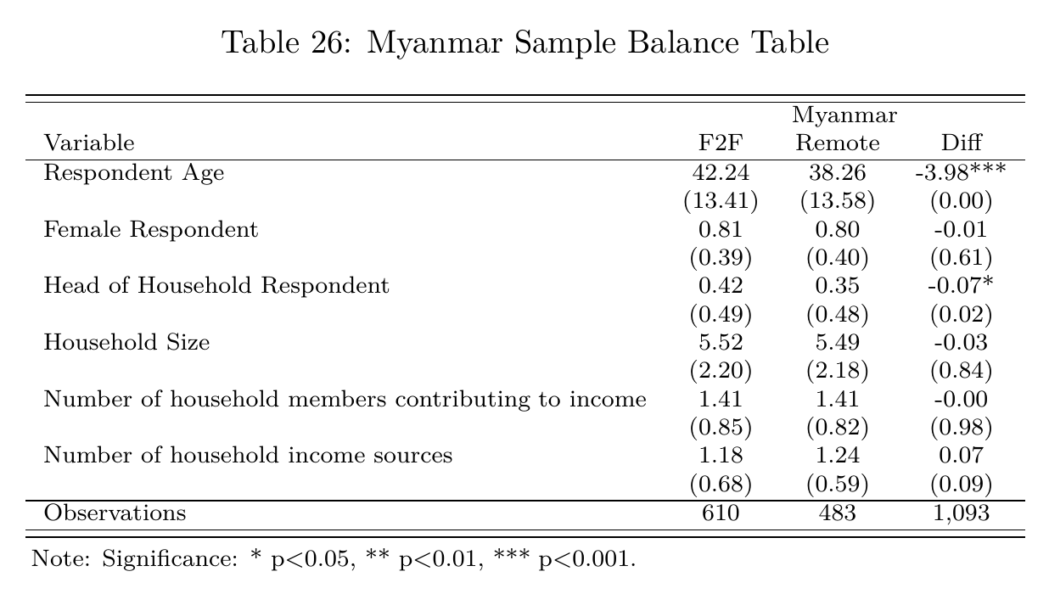
Table (1-2) Balance of the background variables of Myanmar study population (after excluding half of the phone survey due to mistake in the FES module translation to local language)
During the analysis of Myanmar sample, half of the expenditure data collected through phone survey were dropped due to some errors in translating the expenditure module to the local language. However, as this mistake was only restricted to the randomly assigned half of the questionnaires, the sampling balance was not affected (see table 1-2). Any analysis involving FES will is only restricted to the sample without the error forms i.e., 610 households F2F and only 232 households remote.
Table (1-3) Balance of the background variables of Ecuador study population
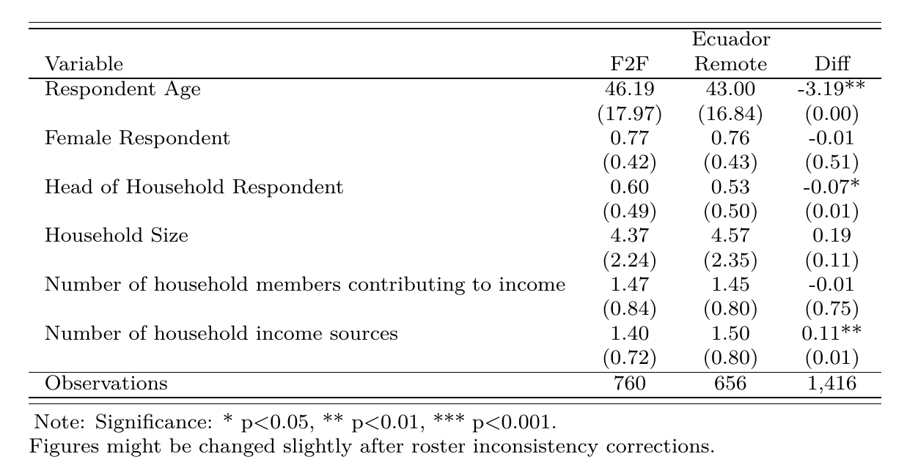
Table (1-4) Balance of the background variables of Ecuador study population
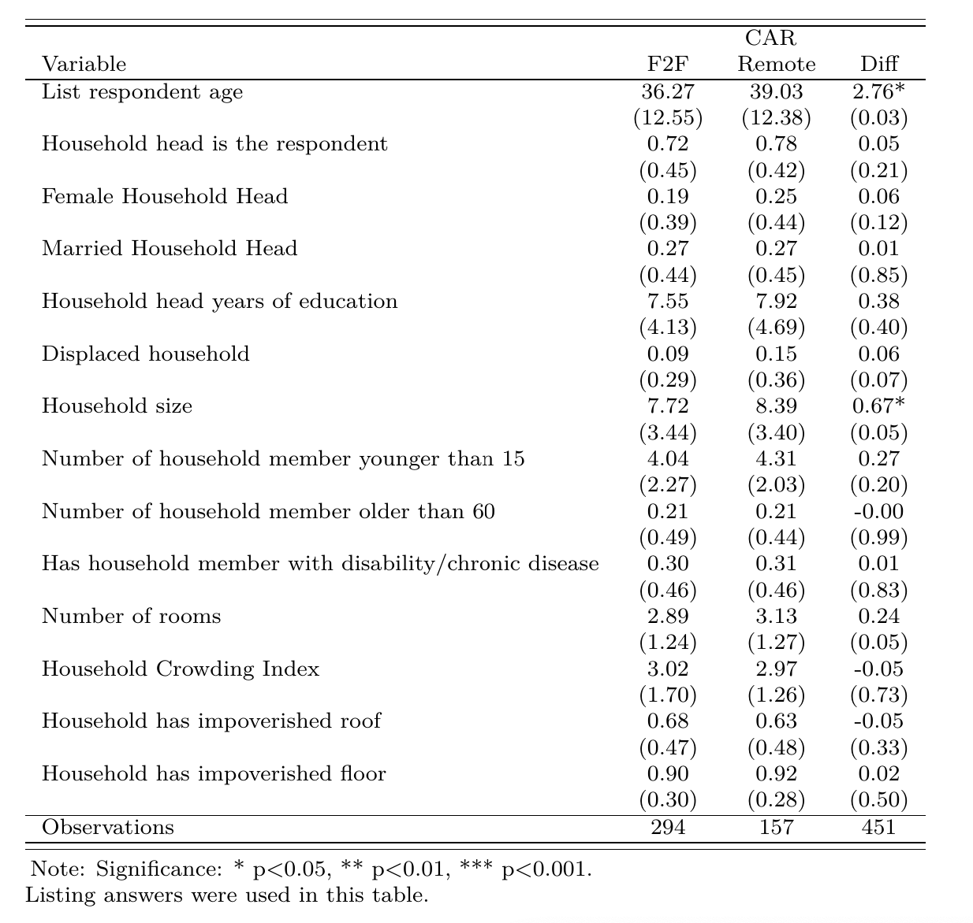

Annex II

Table (2-1): Myanmar: Each Coping Strategy Used
 |  | Myanmar
Variable | F2F | Remote | Diff
Used Stress coping: Sold household assets/goods | 0.07 | 0.13 | 0.06**
 | (0.26) | (0.33) | (0.00)
Used Stress coping: Purchased food/non-food on credit (incur debts) | 0.53 | 0.67 | 0.14***
 | (0.50) | (0.47) | (0.00)
Used Stress coping: Spent savings | 0.24 | 0.32 | 0.08**
 | (0.42) | (0.47) | (0.00)
Used Stress coping: Borrowed money | 0.42 | 0.65 | 0.23***
 | (0.49) | (0.48) | (0.00)
Used Crisis coping: Sold productive assets or means of transport | 0.02 | 0.06 | 0.04**
 | (0.14) | (0.23) | (0.00)
Used Crisis coping: Reduced expenses on health | 0.25 | 0.40 | 0.15***
 | (0.43) | (0.49) | (0.00)
Used Crisis coping: Withdrew children from school | 0.01 | 0.06 | 0.05***
 | (0.10) | (0.25) | (0.00)
Used Emergency coping: Send children to work for household income | 0.01 | 0.05 | 0.04***
 | (0.11) | (0.23) | (0.00)
Used Emergency coping: Begged and/or scavenged | 0.01 | 0.03 | 0.02*
 | (0.11) | (0.18) | (0.02)
Used Emergency coping: Engaged in illegal income activities | 0.02 | 0.07 | 0.05***
 | (0.13) | (0.26) | (0.00)
Observations | 610 | 483 | 1,093
Note: Significance: * p<0.05, ** p<0.01, *** p<0.001.

Table (2-2): Ecuador: Each Coping Strategy Used
 |  | Ecuador
Variable | F2F | Remote | Diff
Used Stress coping: Sold household assets/goods | 0.10 | 0.15 | 0.05**
 | (0.31) | (0.36) | (0.01)
Used Stress coping: Purchased food/non-food on credit (incur debts) | 0.39 | 0.31 | -0.08**
 | (0.49) | (0.46) | (0.00)
Used Stress coping: Spent savings | 0.62 | 0.65 | 0.03
 | (0.49) | (0.48) | (0.18)
Used Stress coping: Borrowed money | 0.64 | 0.64 | 0.01
 | (0.48) | (0.48) | (0.80)
Used Crisis coping: Sold productive assets or means of transport | 0.05 | 0.08 | 0.03
 | (0.23) | (0.27) | (0.06)
Used Crisis coping: Reduced expenses on health and education | 0.57 | 0.61 | 0.04
 | (0.50) | (0.49) | (0.10)
Used Crisis coping: Withdrew children from school | 0.08 | 0.11 | 0.03
 | (0.27) | (0.31) | (0.07)
Used Emergency coping: Send children to work for household income | 0.08 | 0.09 | 0.01
 | (0.27) | (0.28) | (0.53)
Used Emergency coping: Begged and/or scavenged | 0.10 | 0.23 | 0.13***
 | (0.29) | (0.42) | (0.00)
Used Emergency coping: Engaged in illegal income activities | 0.09 | 0.58 | 0.49***
 | (0.28) | (0.49) | (0.00)
Observations | 760 | 656 | 1,416
Note: Significance: * p<0.05, ** p<0.01, *** p<0.001.
Table (2-3): CAR: Each Coping Strategy Used
 |  | CAR
Variable | F2F | Remote | Diff
Used Stress coping: Sold household assets/goods | 0.28 | 0.46 | 0.18***
 | (0.45) | (0.50) | (0.00)
Used Stress coping: Reduced expenses on health and education | 0.23 | 0.43 | 0.20***
 | (0.42) | (0.50) | (0.00)
Used Stress coping: Spent savings | 0.47 | 0.50 | 0.03
 | (0.50) | (0.50) | (0.50)
Used Stress coping: Borrowed money | 0.46 | 0.53 | 0.07
 | (0.50) | (0.50) | (0.18)
Used Crisis coping: Sold productive assets or means of transport | 0.07 | 0.26 | 0.19***
 | (0.26) | (0.44) | (0.00)
Used Crisis coping: Moved to somewhere else | 0.05 | 0.14 | 0.09**
 | (0.23) | (0.35) | (0.01)
Used Crisis coping: Withdrew children from school | 0.03 | 0.05 | 0.02
 | (0.17) | (0.22) | (0.32)
Used Emergency coping: Sold houses | 0.03 | 0.14 | 0.11***
 | (0.17) | (0.35) | (0.00)
Used Emergency coping: Begged and/or scavenged | 0.01 | 0.07 | 0.06**
 | (0.12) | (0.26) | (0.01)
Used Emergency coping: Engaged in illegal income activities | 0.01 | 0.03 | 0.02
 | (0.10) | (0.16) | (0.27)
Observations | 294 | 157 | 451
Note: Significance: * p<0.05, ** p<0.01, *** p<0.001.

Annex III
Figure (3-1) Ecuador sampling
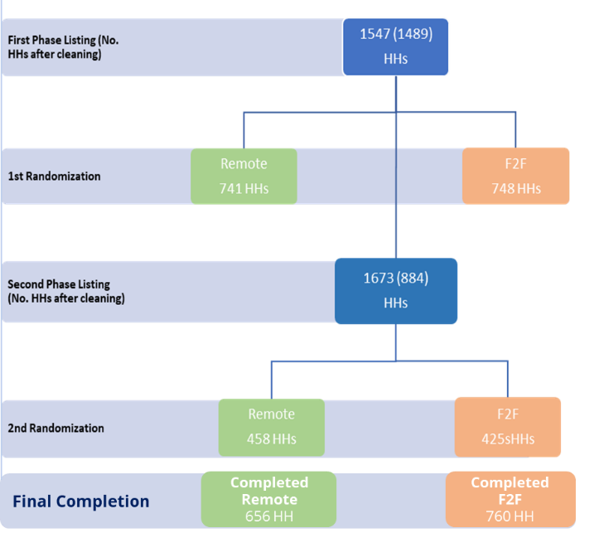
In Ecuador, 1547 households were randomized however, having 741 Households in each arm of the study was not enough to reach the minimum sample size required (600 HH) a second round of listing and randomization took place for extra 1673 household to be able to reach the minimum sample size.
Figure (3-2) Sample design for CAR
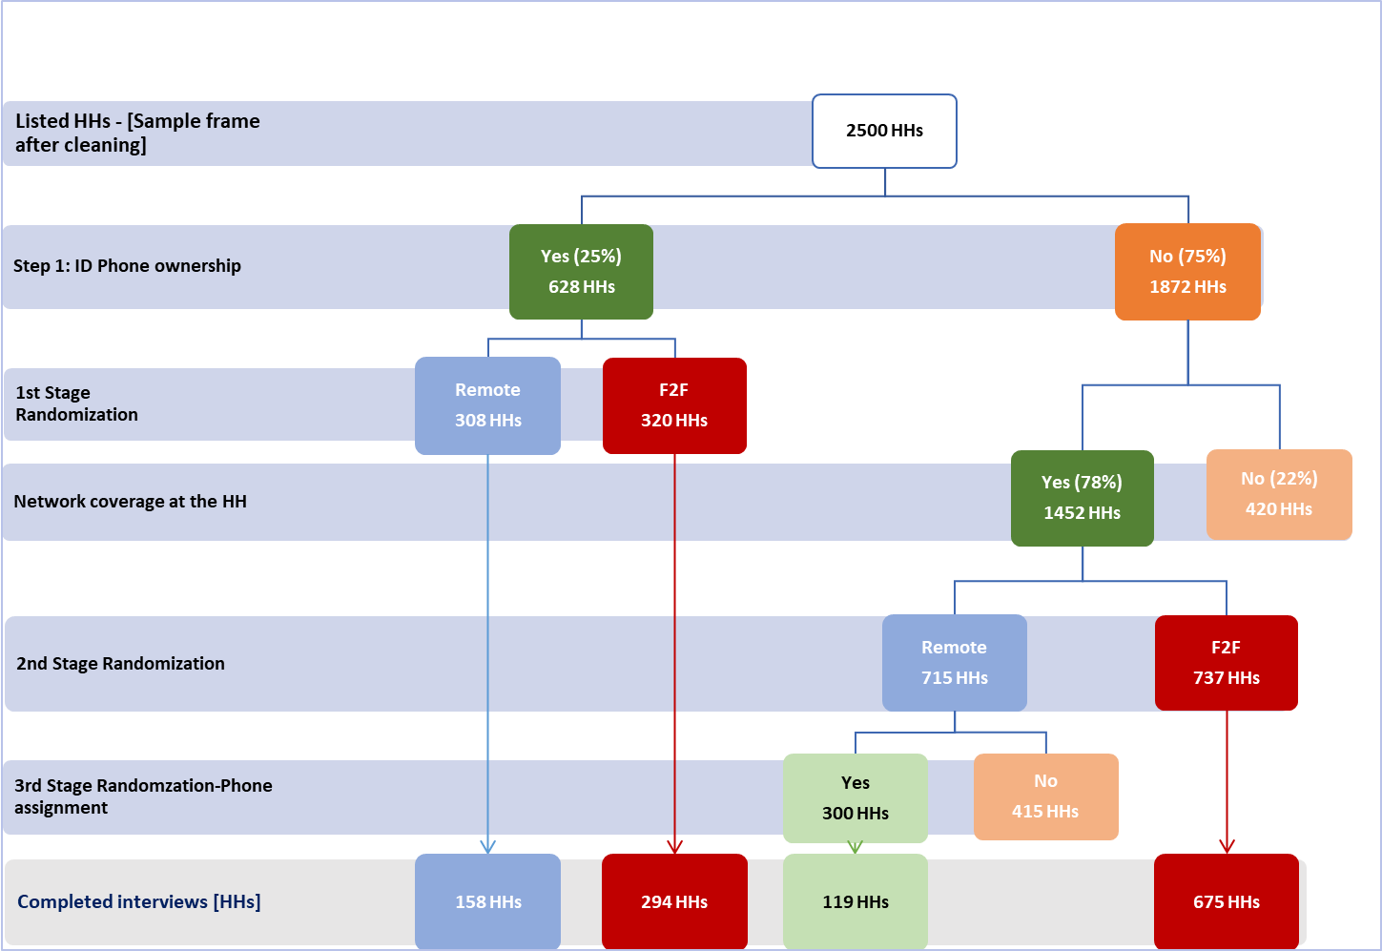
In CAR, there were 2 layers of randomization. First layer was done among the phone owner, then a second layer among the non-phone owners. For the non-phone owners, after randomization, households that were randomized to receive phone survey were handed cheap mobile phone to receive the phone interview through it. Nevertheless, network coverage stood against high response rate in the two subsamples (mobile owners and non-mobile owners).
For this preliminary analysis, only mobile owner sample (294 households Face to face, and 167 remote) was included as the primary objective of the study is to collect information from statistically comparable population (in this case mobile-phone owners). See the statistical balanced test form CAR mobile owner sample in (Annex I). Further modeling could be done to control for the network coverage and mobile phone ownership as a secondary objective of the study.

Annex IV
- CARI methodology Consolidated Approach for Reporting Indicators of Food Security (CARI) Guidelines - Third edition
- FCS https://resources.vam.wfp.org/data-analysis/quantitative/food-security/food-consumption-score
- FCS https://resources.vam.wfp.org/data-analysis/quantitative/food-security/food-consumption-score
- rCSI https://resources.vam.wfp.org/data-analysis/quantitative/food-security/reduced-coping-strategies-index
- LCS https://resources.vam.wfp.org/data-analysis/quantitative/food-security/livelihood-coping-strategies-food-security
- FES https://resources.vam.wfp.org/data-analysis/quantitative/food-security/food-expenditure-share
Income sources and changes syntax
- rCARI for both F2F and Remote (different choices than the guidance so I made some assumptions):
  - Replace rCARI == 1 when
    - Income source is Wage Labor – Professional/ Skilled; Pension; Small/Medium/large trade (own business); Small/Medium/Large Agriculture production including livestock (own or rented land/owned livestock)
    - Income change is increase, no change or alternative source
  - Replace rCARI == 2 when
    - Income source is Wage Labor – Professional/ Skilled; Pension; Small/Medium/large trade (own business); Small/Medium/Large Agriculture production including livestock (own or rented land/owned livestock)
    - Income change is reducing
OR
    - Income source is Wage Labor - Unskilled/Casual/Agriculture/Unskilled/Casual/non-agriculture; Remittances; Petty trade/selling on streets
    - Income change is increase, no change or alternative source
  - Replace rCARI == 3 when
  - Income source is Wage Labor - Unskilled/Casual/Agriculture/Unskilled/Casual/non-agriculture; Remittances; Petty trade/selling on streets
  - Income change is reducing
  - Replace rCARI == 4 when
  - No income source or income source is Aid/gifts; Borrowing money/Living off debt; High-risk activities; Begging, scavenging; Saving/selling assets
  - Missing rCARI when income source is marked as Other Specify

This was a makeshift arrangement since the team did not have access to the field to conduct a primary listing of households due to restrictions by local authorities.
For a background on how these individual indicators are aggregated and included into each methodology, refer to Annex IV

